Plataforma Web para adopción y bienestar animal PetConnect

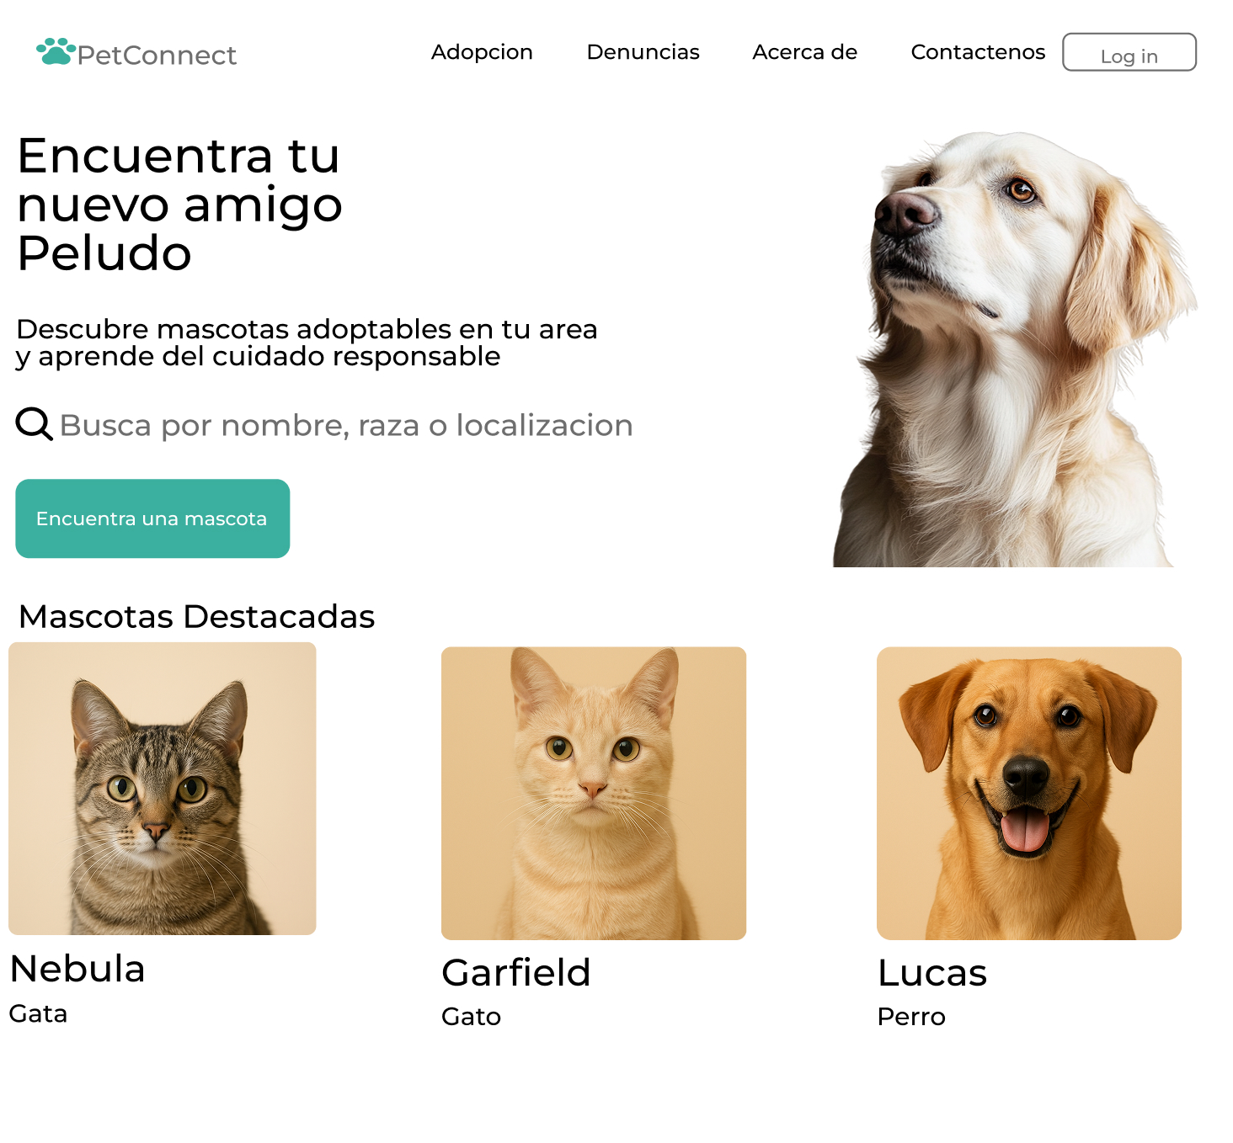

Link del prototipo: https://www.figma.com/design/F1N8m1LjoTrf1FDMdJEImS/Adoption-pet-website-ui?node-id=8-4&t=wQaeNibPngTeBpo4-1